INTRODUCTION TO PYTHON

Python is an object-oriented, high level language, interpreted, dynamic and multipurpose programming language.
Python is designed to be highly readable.
Python is Easy-to-read: Python code is more clearly defined and visible to the eyes.
Python Easy-to-maintain: Python's source code is fairly easy-to-maintain.
Python is Interpreted Language: Python is an interpreted language i.e. interpreter executes the code line by line at a time. This makes debugging easy and thus suitable for beginners.
Python is Object-Oriented: Python supports Object-Oriented style or technique of programming that encapsulates code within objects.
Python supports multiple programming pattern, including object oriented programming, imperative and functional programming or procedural styles.
Python Cross-platform Language: Python can run equally on different platforms such as Windows, Linux, UNIX, Macintosh etc. Thus, Python is a portable language.
Python Free and Open Source: Python language is freely available (www.python.org).The source-code is also available. Therefore it is open source.
Python Extensible: It implies that other languages such as C/C++ can be used to compile the code and thus it can be used further in your python code.
Python broad standard library: Python's bulk of the library is very portable and cross-platform compatible on UNIX, Windows, and Macintosh.
GUI Programming: Graphical user interfaces can be developed using Python.
Integrated: It can be easily integrated with languages like C, C++, and JAVA etc.
Python is free software and it can be downloaded from www.python.org

HISTORY OF PYTHON
Python was developed by Guido van Rossum in the late eighties and early nineties at the National Research Institute for Mathematics and Computer Science in the Netherlands.
Guido van Rossum started implementing Python as a hobby project in 1989 Christmas holidays. It was named after BBC comedy show Monty Python’s Flying circus.
Python is now maintained by a core development team at the institute, although Guido van Rossum still holds a vital role in directing its progress.

Python Applications
Python as a whole can be used in any sphere of development.

Console Based Application:
Python can be used to develop console based applications. For example: IPython.

Audio or Video based Applications
Python proves handy in multimedia section. Some of real applications are: TimPlayer, cplay etc.

3D CAD Applications
Fandango is a real application which provides full features of CAD.

Web Applications
Python can also be used to develop web based application. Some important developments are: PythonWikiEngines, Pocoo, PythonBlogSoftware etc.

Enterprise Applications
Python can be used to create applications which can be used within an Enterprise or an Organization. Some real time applications are: OpenErp, Tryton, Picalo etc.

Applications for Images
Using Python several applications can be developed for image. Applications developed are:
VPython, Gogh, imgSeek etc.
How to Execute Python

Using IDE: (Integrated Development Environment)
You can execute your Python code using a Graphical User Interface (GUI).
All you need to do is:
Click on Start button -> All Programs -> Python -> IDLE (Python GUI)
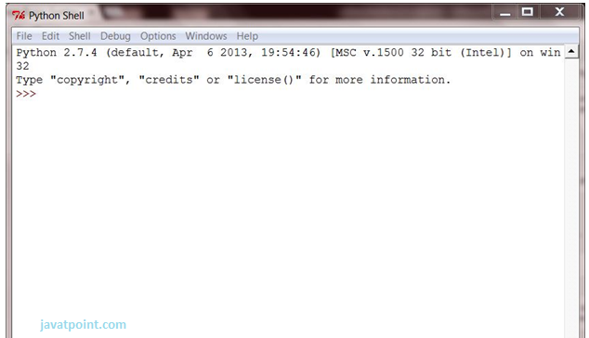
You can use both Interactive as well as Script mode in IDE.
1) Using Interactive mode:
Execute your Python code on the Python prompt and it will display result simultaneously.
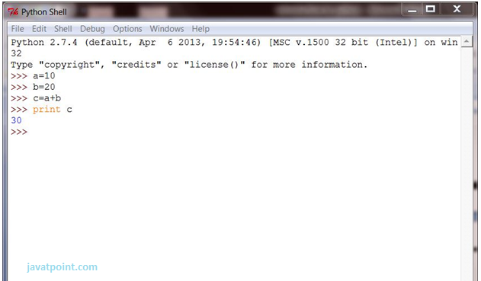

2) Using Script Mode:
i) Click on Start button -> All Programs -> Python -> IDLE (Python GUI)
ii) Python Shell will be opened. Now click on File -> New Window.
A new Editor will be opened. Write your Python code here.
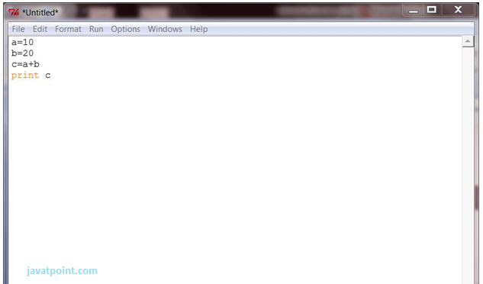
Click on file -> save as file name.py
Run then code by clicking on Run in the Menu bar.
Run -> Run Module
Result will be displayed on a new Python shell as:

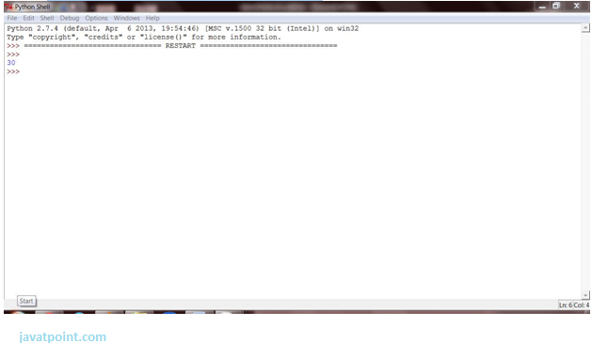

Python Variables
Variable is a name of the memory location where data is stored. Once a variable is stored that means a space is allocated in memory.

Assigning values to Variable:
We need not to declare explicitly variable in Python. When we assign any value to the variable that variable is declared automatically.
The assignment is done using the equal (=) operator.
Eg:
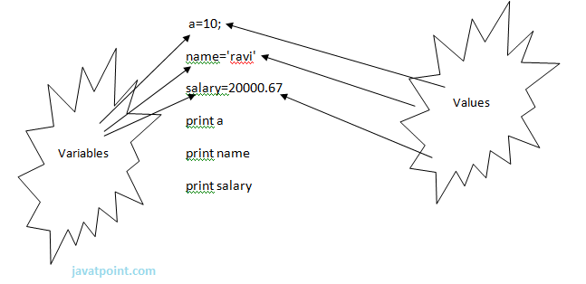

Multiple Assignment:

Multiple assignments can be done in Python at a time. There are two ways to assign values in Python:
1. Assigning single value to multiple variables:
Eg:
- x=y=z=50
- print (x)
- print (y)
- print (z)
2. Assigning multiple values to multiple variables:
Eg:
- a,b,c=5,10,15
- print (a)
- print (b)
- print (c)
The values will be assigned in the order in which variables appears.

Standard Data Types

The data stored in memory can be of many types. For example, a person's age is stored as a numeric value and his or her address is stored as alphanumeric characters. Python has various standard data types that are used to define the operations possible on them and the storage method for each of them.
Python has five standard data types −
- Numbers
- String
- List
- Tuple
- Dictionary
(List, Tuple and Dictionary are known as Compound data types.)

Basic Fundamentals:
This section contains the basic fundamentals of Python like:
i) Tokens and their types.
ii) Comments
A) Tokens:
- Tokens can be defined as a punctuator mark, reserved words and each individual word in a statement.
- Token is the smallest unit inside the given program.
There are following tokens in Python:
- Keywords.
- Identifiers.
- Literals.
- Operators.

Python Keywords
Keywords are special reserved words which convey a special meaning to the compiler/interpreter. Each keyword have a special meaning and a specific operation.
[‘False’, 'None', 'True', 'and', 'as', 'assert', 'break', 'class', 'continue',
'def', 'del', 'elif', 'else', 'except', 'finally', 'for', 'from', 'global',
'if', 'import', 'in', 'is', 'lambda', 'nonlocal', 'not', 'or', 'pass', 'raise', 'return',
'try', 'while', 'with', ‘yield’ ] = 33 keywords

Identifiers

Identifiers are the names given to the fundamental building blocks in a program.
These can be variables, class, object, functions, lists, dictionaries etc.
There are certain rules defined for naming.
I. An identifier is a long sequence of characters and numbers.
II. No special character except underscore ( _ ) can be used as an identifier.
III. Keyword should not be used as an identifier name.
IV. Python is case sensitive. So using case is significant.
V. First character of an identifier can be character, underscore ( _ ) but not digit.

Python Literals
Literals can be defined as a data that is given in a variable or constant. Python support the following literals:

I. String literals:

String literals can be formed by enclosing a text in the quotes. We can use both single as well as double quotes for a String.

Eg: "Aman" , '12345'

- II. Numeric literals:

Numeric Literals are immutable. Numeric literals can belong to following four different numerical types.
Int(signed integers) | Long(long integers) | float(floating point) | Complex(complex)
Numbers( can be both positive and negative) with no fractional part.eg: 100 | Integers of unlimited size followed by lowercase or uppercase L eg: 87032845L | Real numbers with both integer and fractional part eg: -26.2 | In the form of a+bj where a forms the real part and b forms the imaginary part of complex number. eg: 3.14j
III. Boolean literals:

A Boolean literal can have any of the two values: True or False.

Python Comments
Python supports two types of comments:

1) Single lined comment:

In case user wants to specify a single line comment, then comment must start with? #?

Eg: # This is single line comment.
2) Multi lined Comment:
Multi lined comment can be given inside triple quotes.

Eg: “””

This Is Multiline comment

“””

